Hope

Academy

Project.

Hamza Asif

Colan Barry

Ivan O’Brien

Table of Contents.

Assumptions ----------------------------------------- Pg. 3

Use Case Diagram ---------------------------------- Pg. 3

Sequence Diagrams -------------------------------- Pg. 4 – 7

System Sequence Diagrams ---------------------- Pg. 8 – 10

Interfaces --------------------------------------------- Pg. 11 - 14

Domain Model --------------------------------------- Pg. 15

Design Model ---------------------------------------- Pg. 15

Java Code Generation ------------------------------ Pg. 16

Assumptions

* Singing is classed as an instrument type.
* All instruments are loaned to the student.
* Students can only borrow 1 instrument and partake in lesson for 1 instrument only.
* When a person becomes a student, they receive a student email.
* Passing mark for a grade is 40%.
* Students must register for their own exams.
* Competition takes place regardless if they are entrants.
* Highest mark is input by the tutor.

Use case diagram.

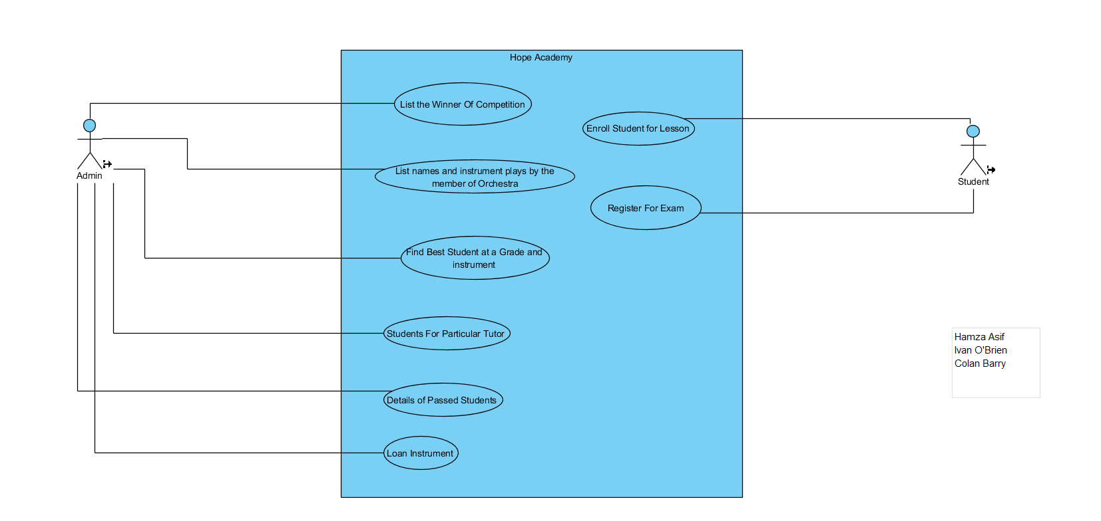

Sequence Diagrams.

Sequence Diagram: Enrolment.

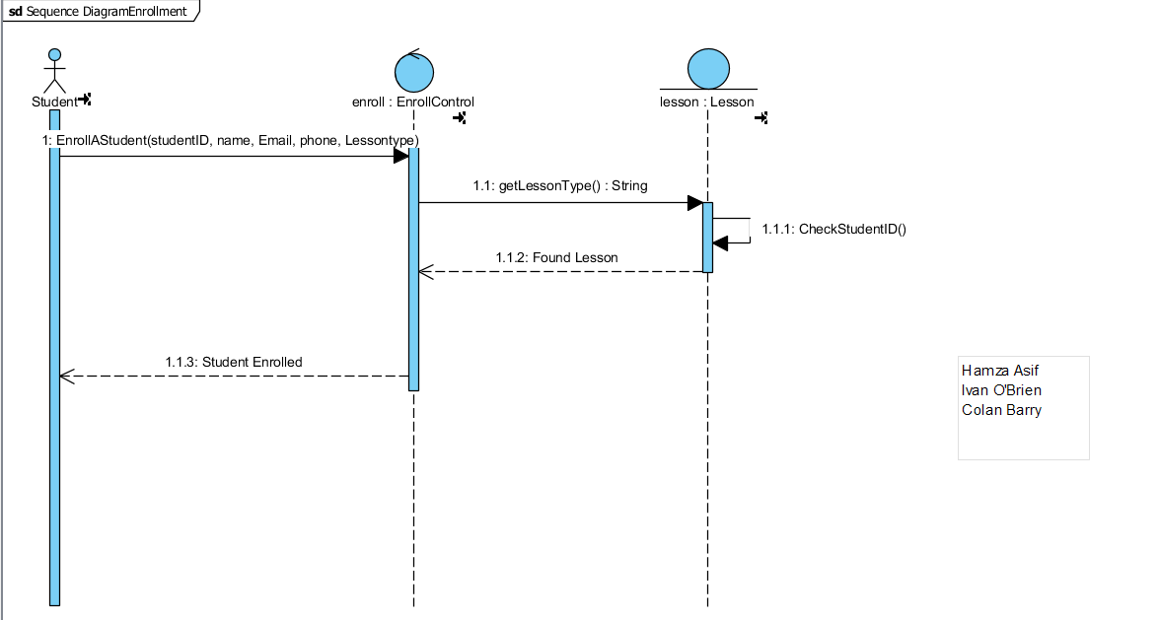

Sequence Diagram: Register for an Exam.

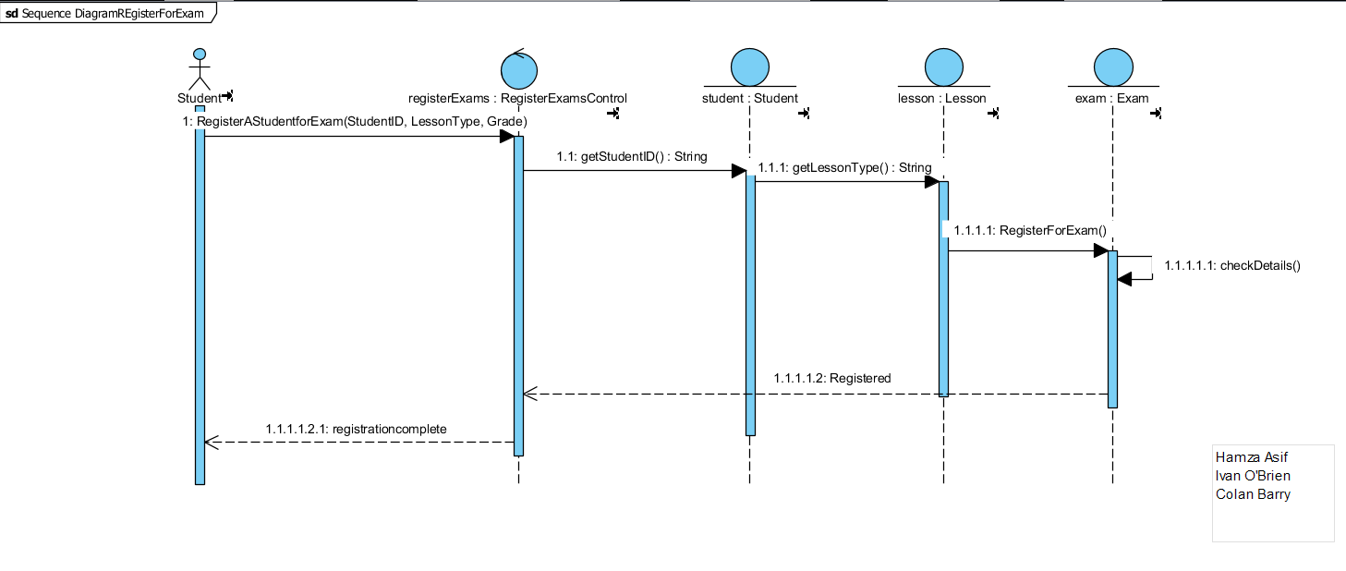

Sequence Diagram: Successful Student.

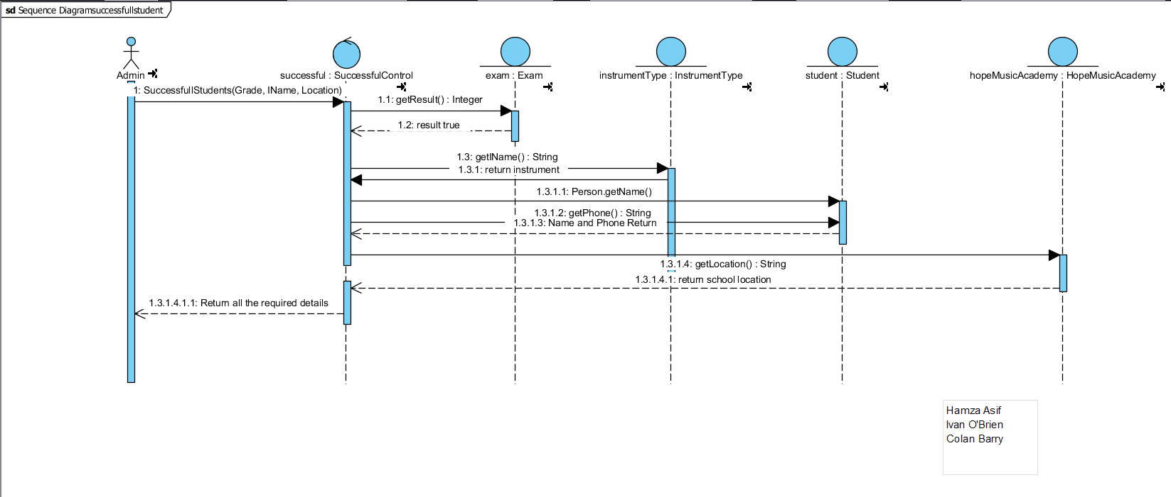

Sequence Diagram: Loan an Instrument.

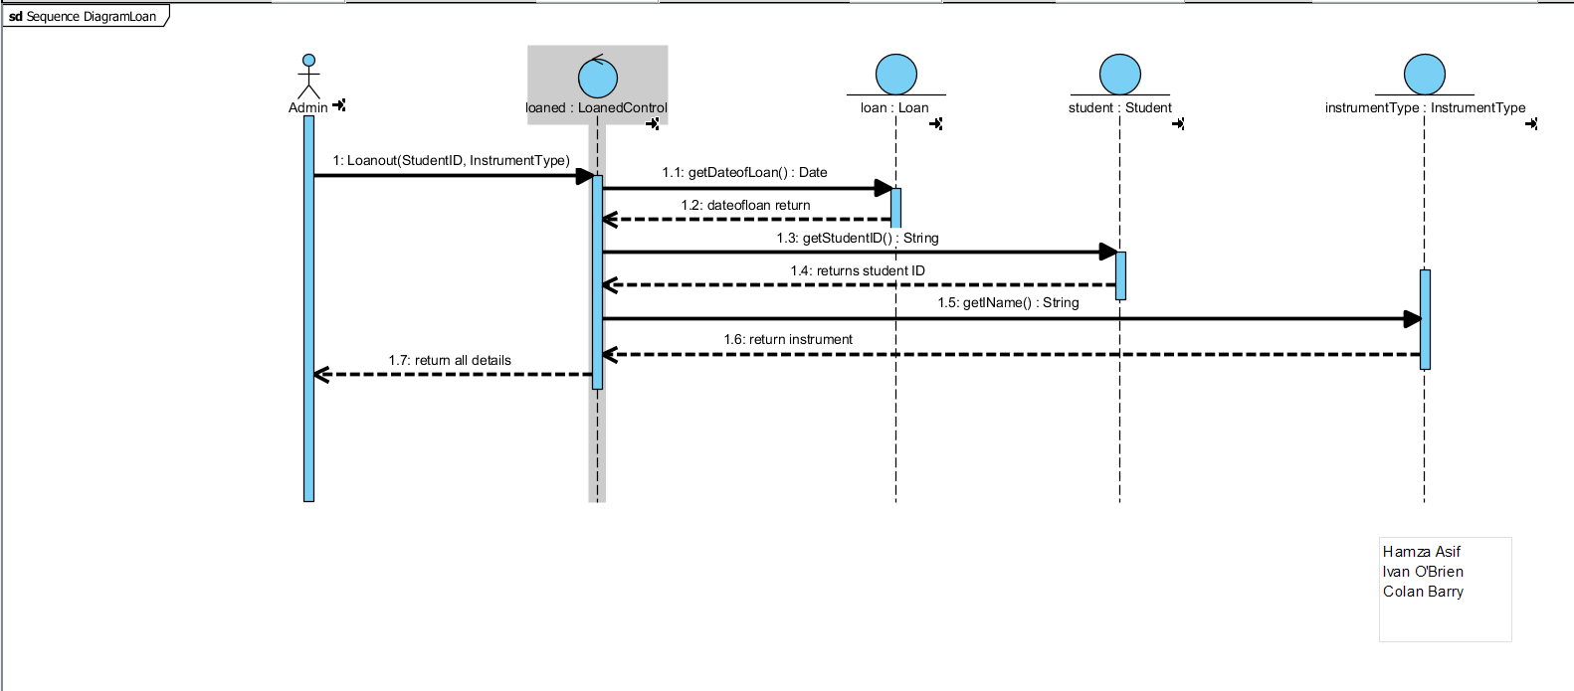

Sequence Diagram: Finding Tutor’s Students.

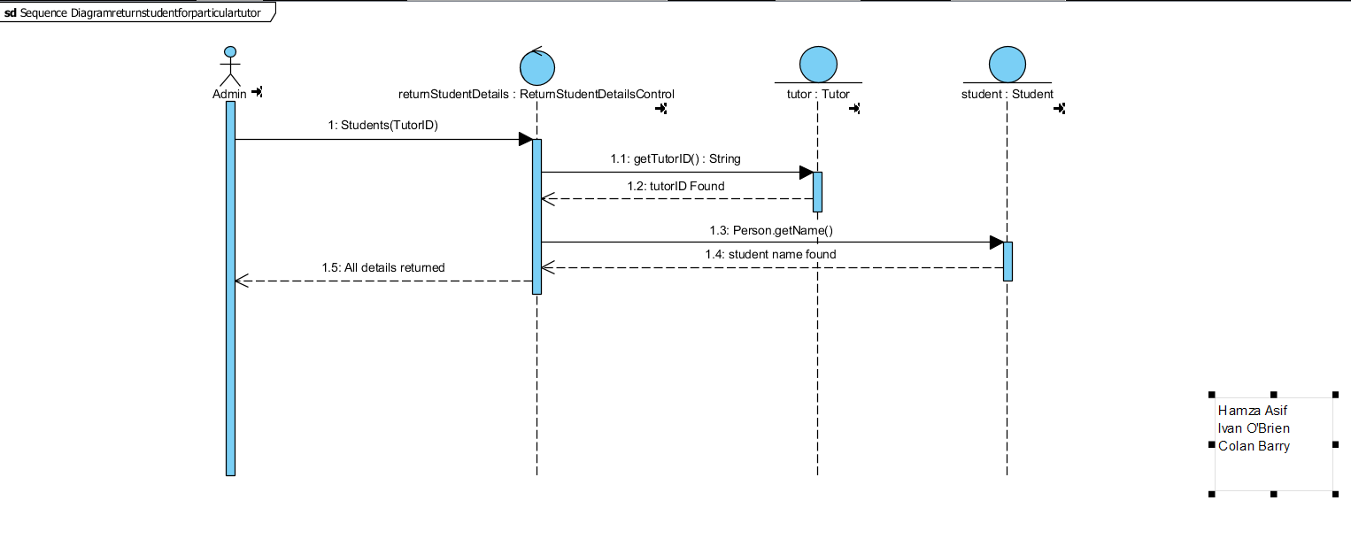

Sequence Diagram: Finding the Best Student.

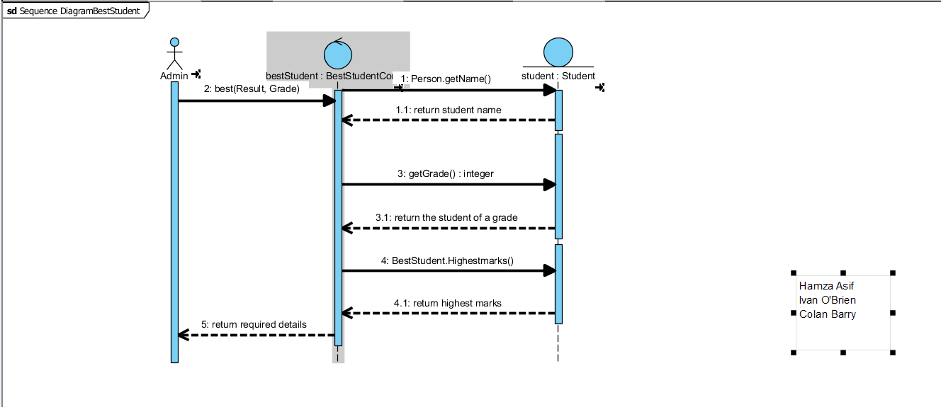

Sequence Diagram: Finding details of the Orchestra Members.

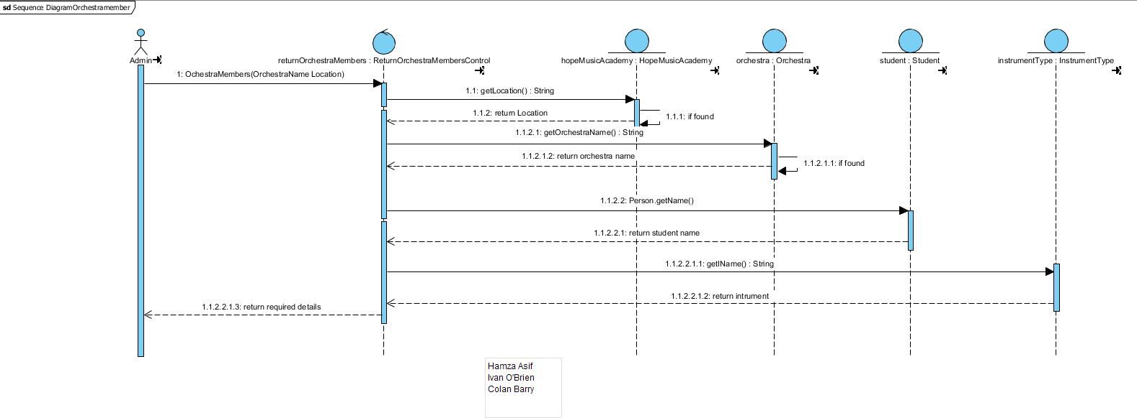

Sequence Diagram: Finding the Competition Winner.

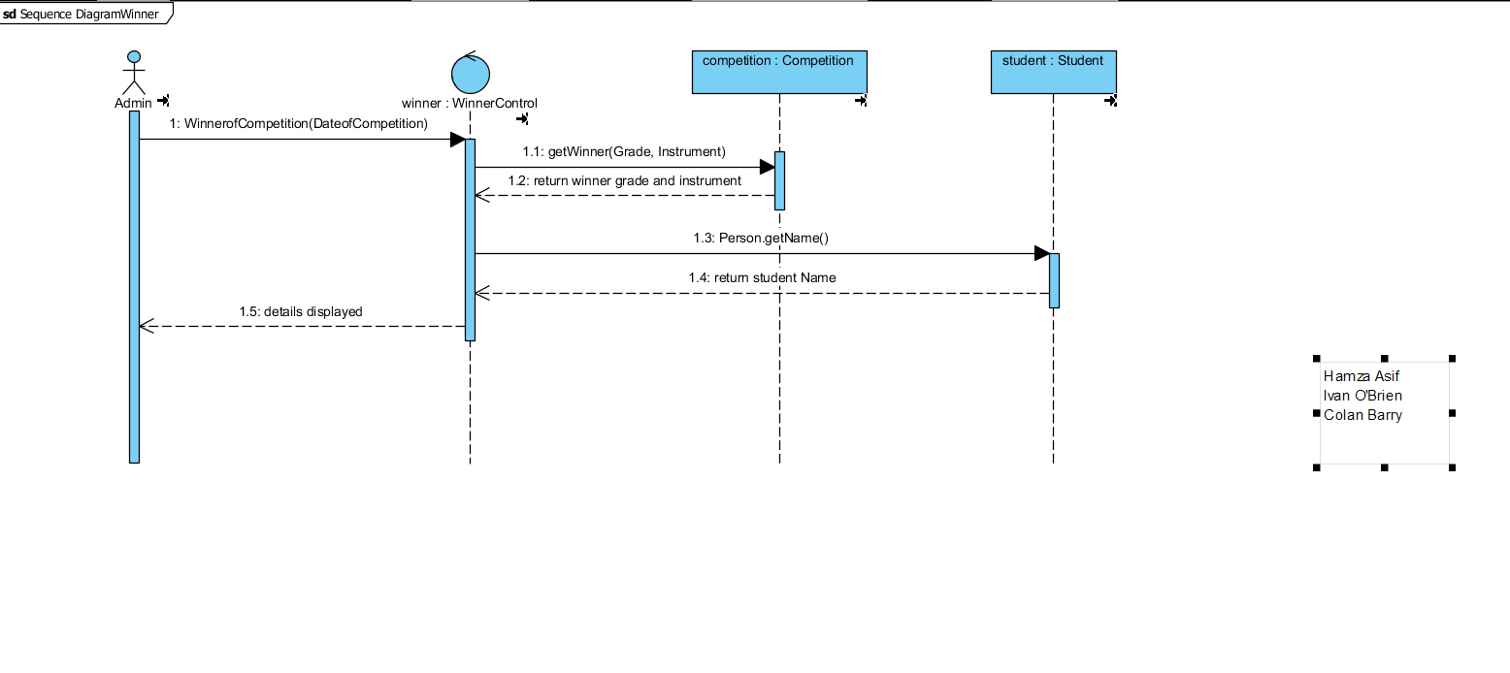

System sequence Diagrams:

System Sequence Diagram: Enrolment.

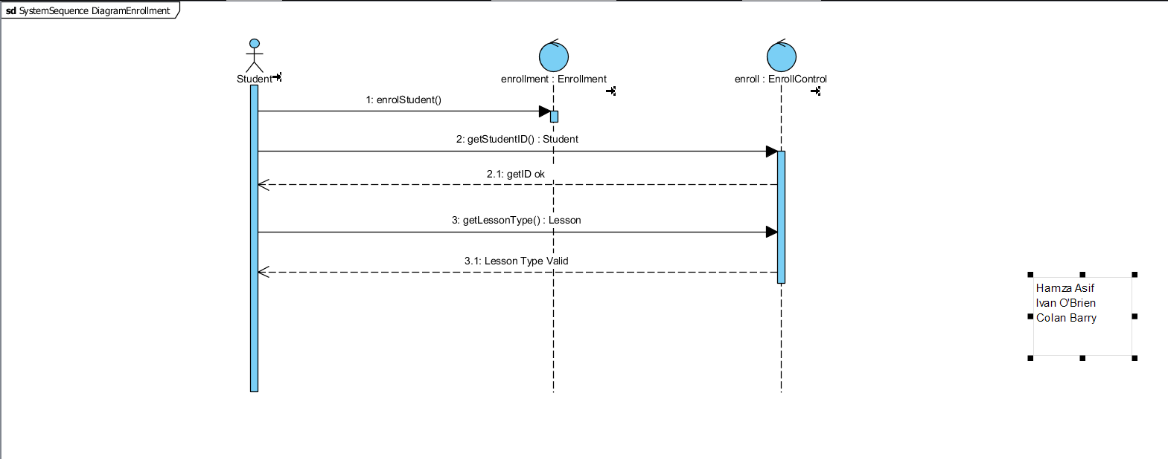

System Sequence Diagram: Registration.

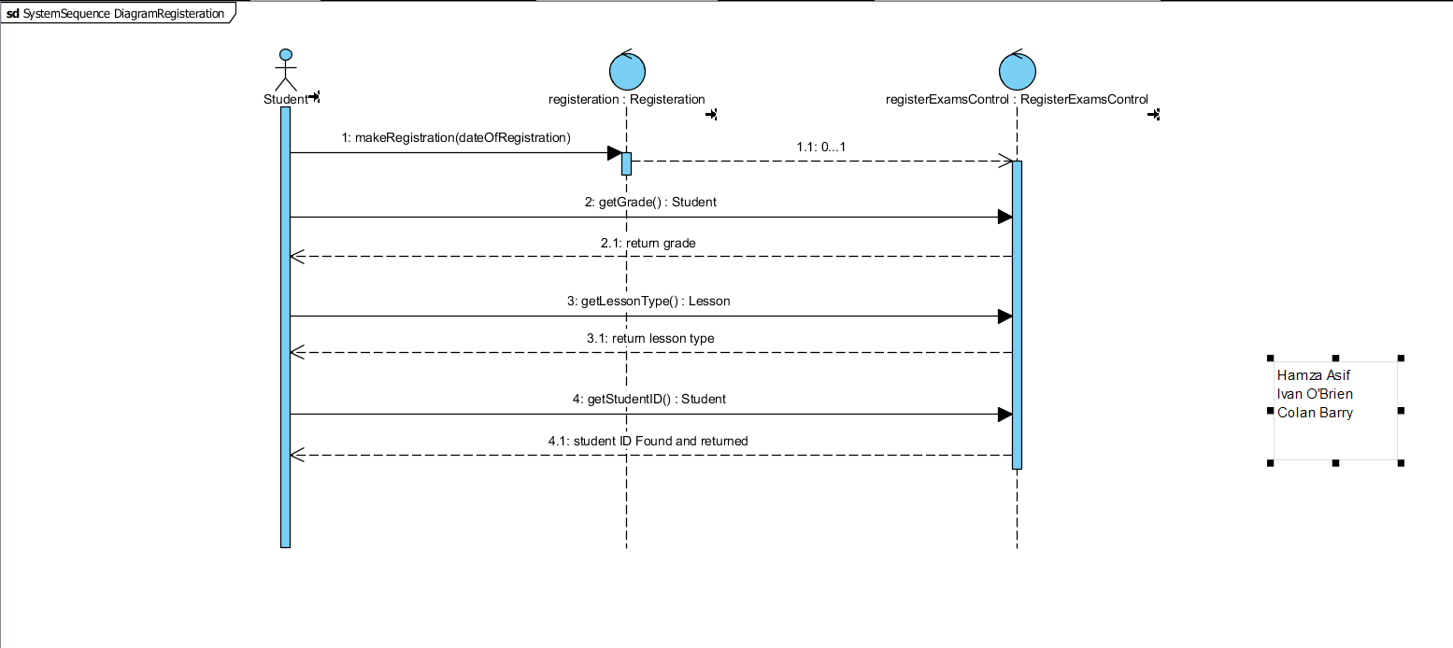

System Sequence Diagram: Loan.

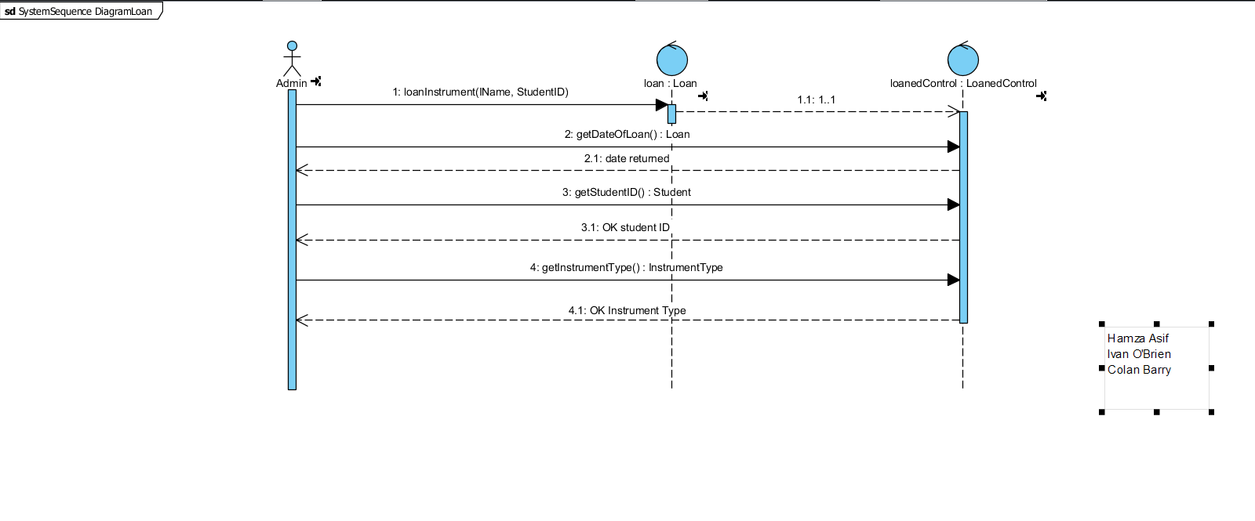

System Sequence Diagram: Successful Student.

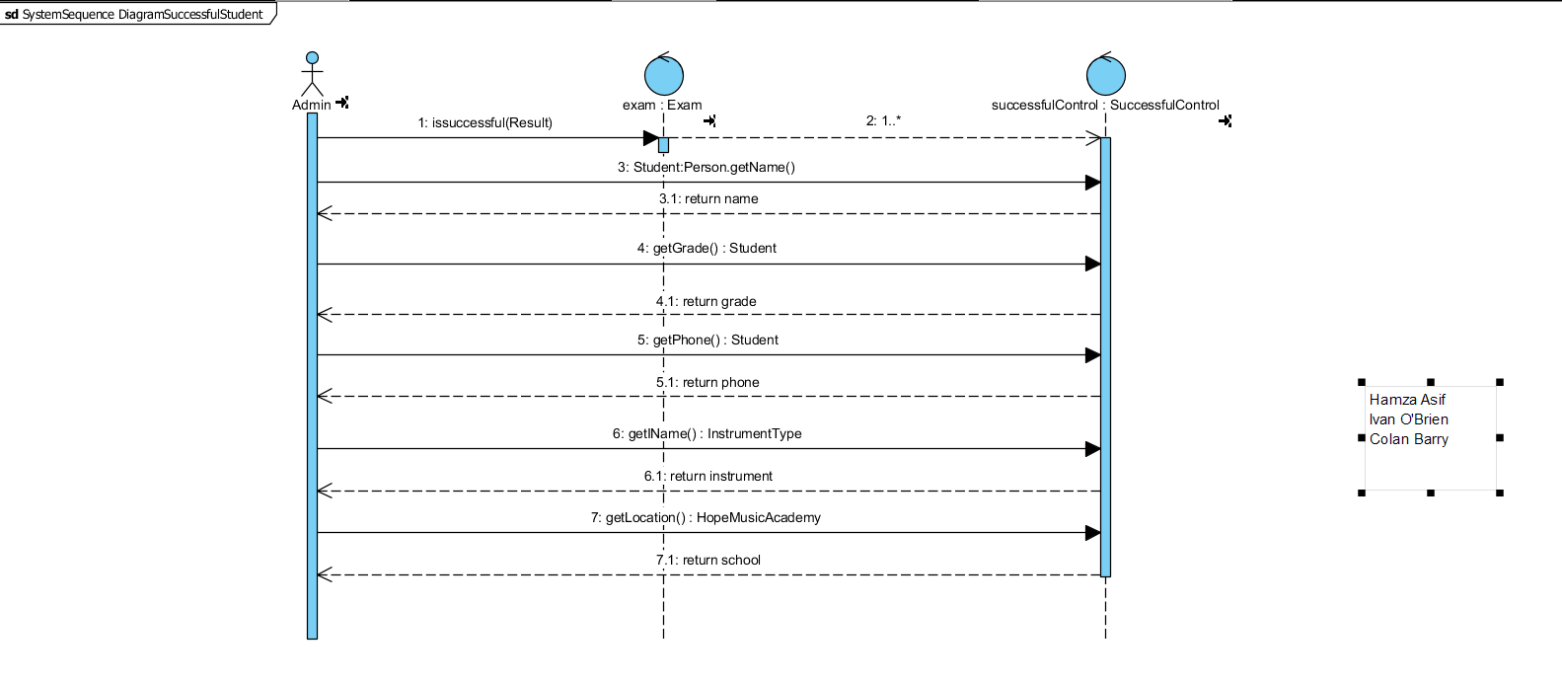

System Sequence Diagram: Finding Tutor’s Students

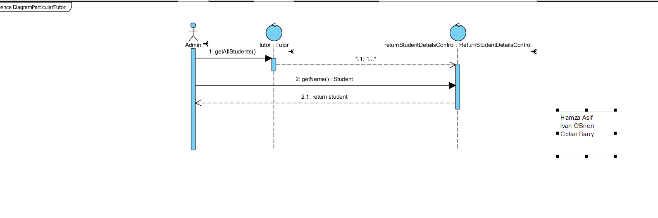

System Sequence Diagram: Best Student

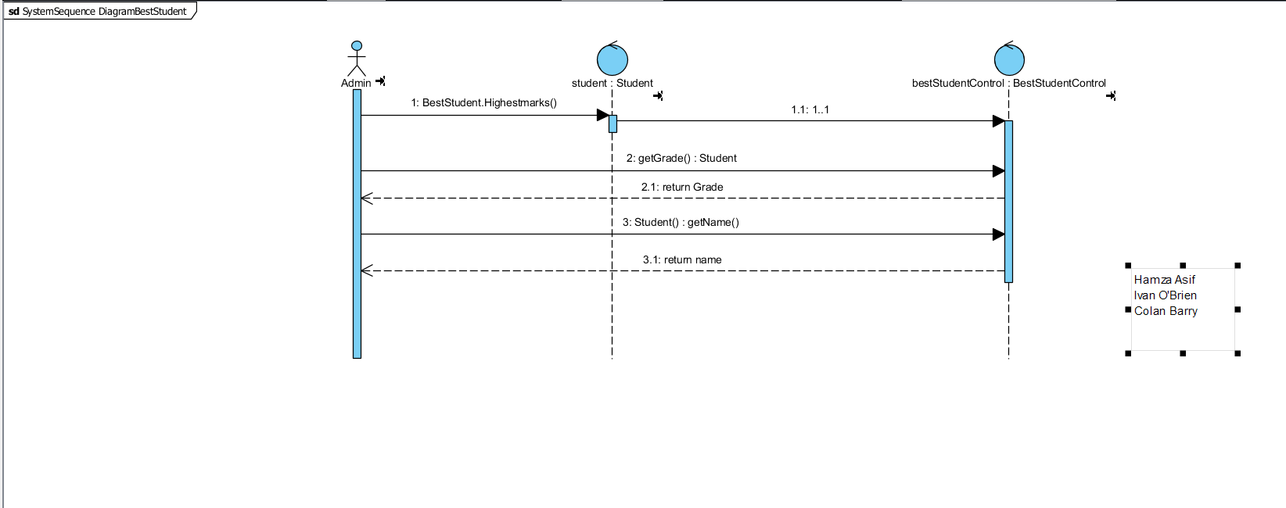

System Sequence Diagram: Orchestra Member Details.

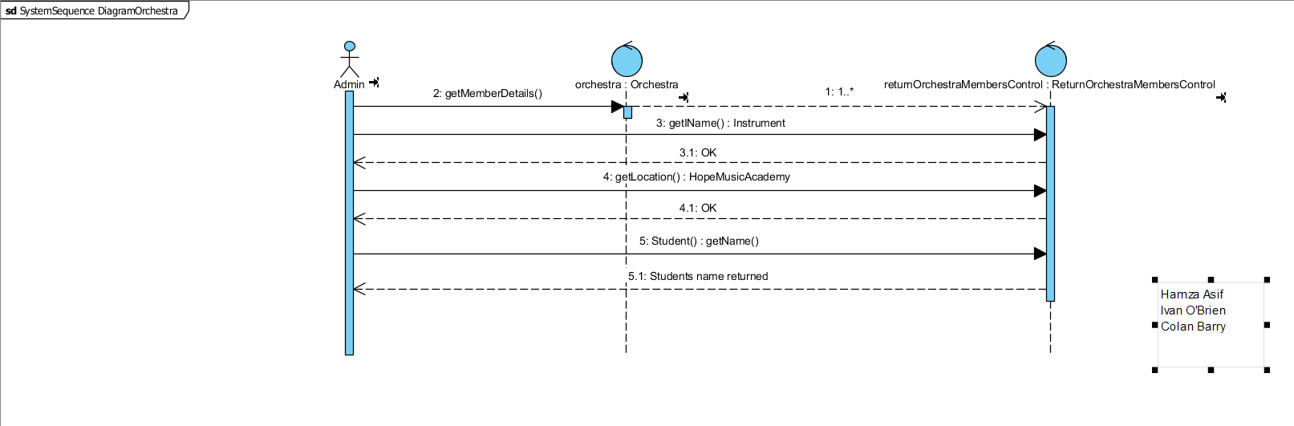

System Sequence Diagram: Competition Winner

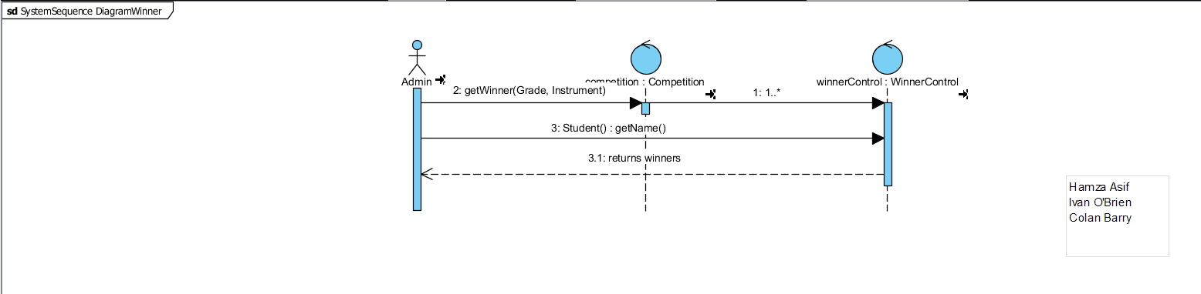

User interfaces

Enrol Student:

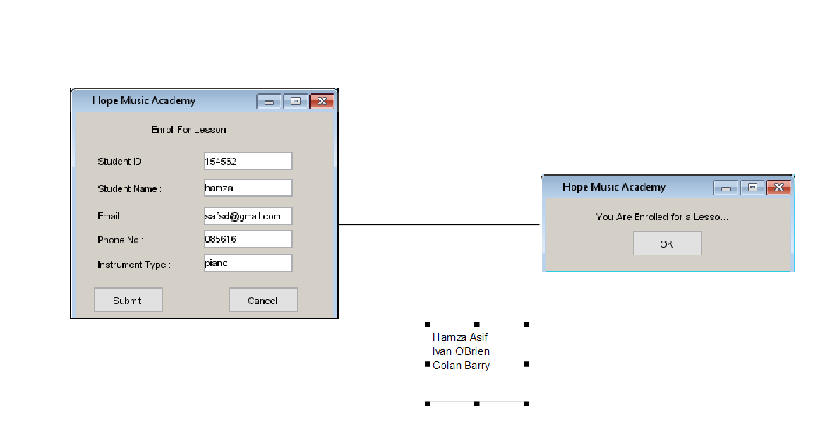

Registration for Exam

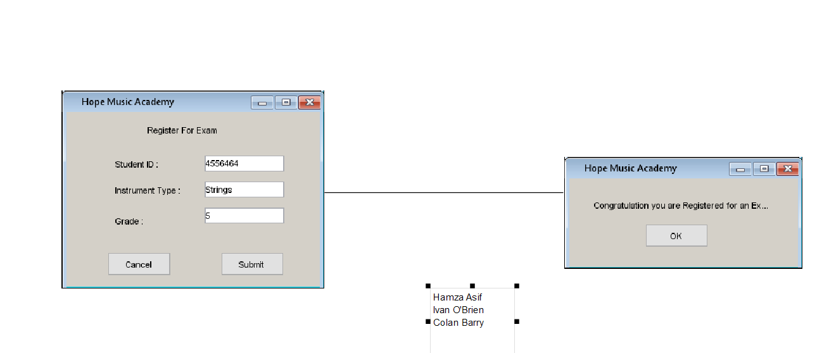

Loaning an Instrument.

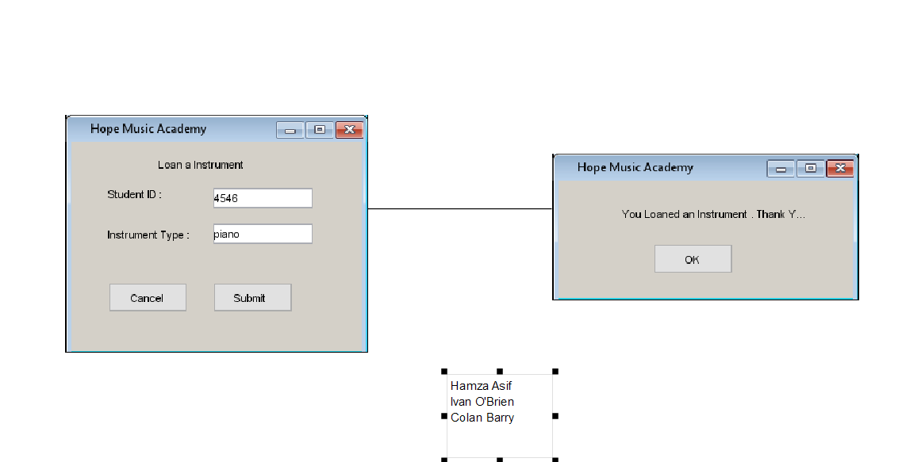

Finding Student Details.

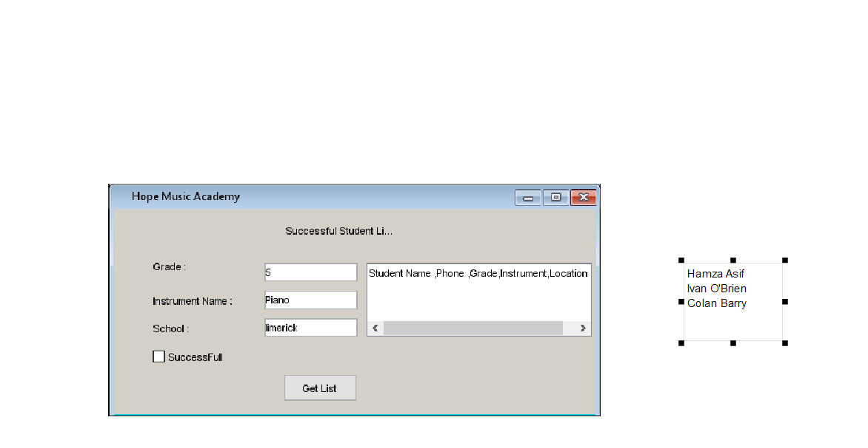

Finding Student with a Certain Tutor.

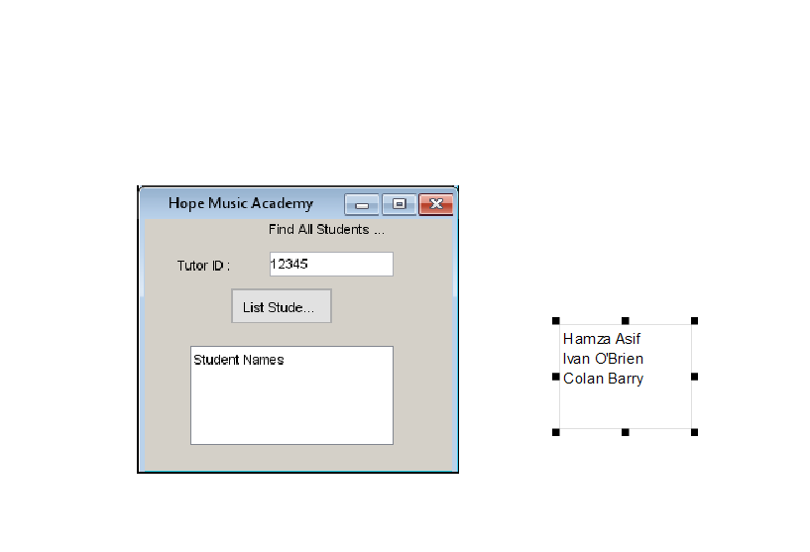

Finding the Best Student.

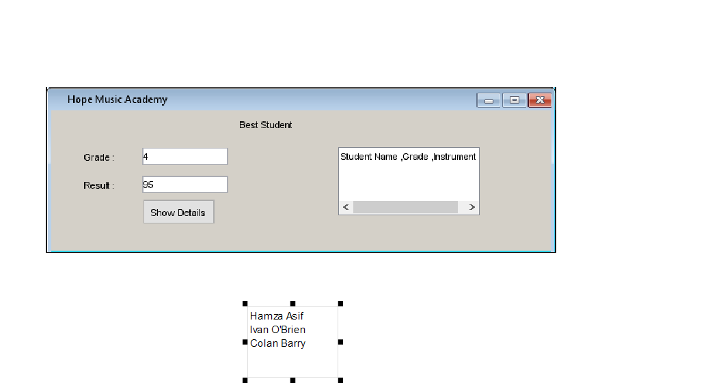

Finding the Orchestra Details.

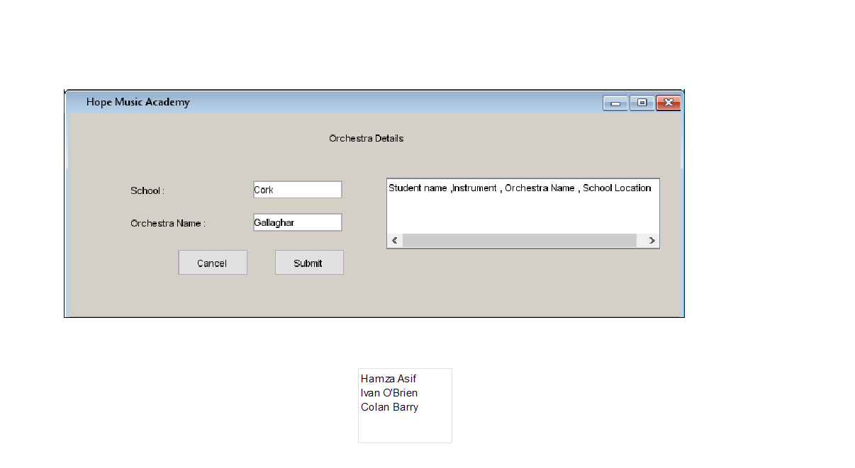

Finding the Competition Winner.

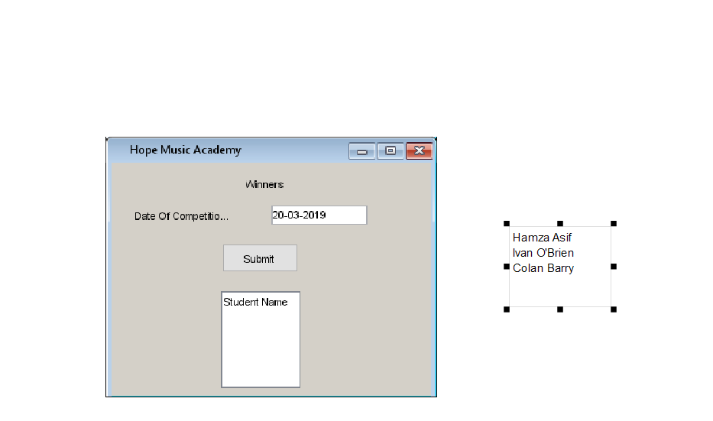

Domain Model:

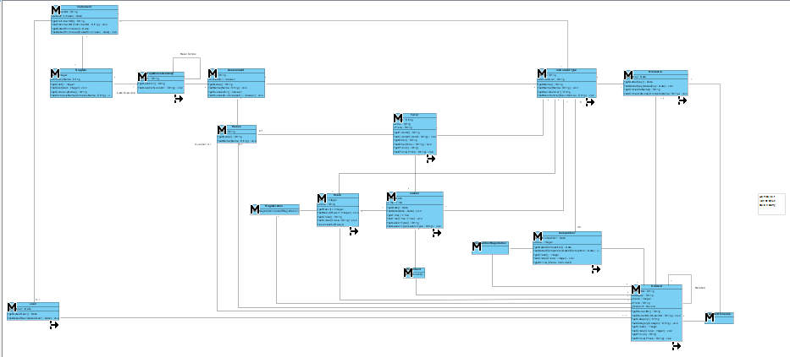

Design Model:

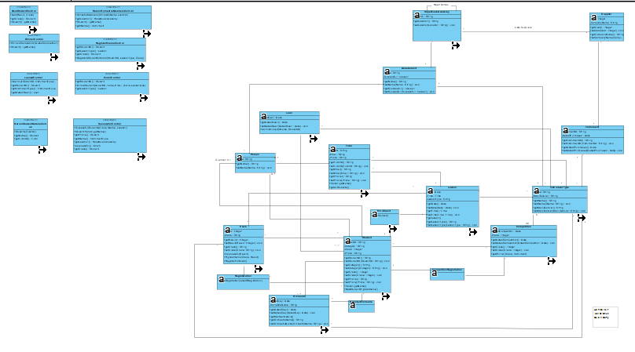

Java Code:

To convert to Java Code.

* Click Tools in the Task Bar.
* Click Arrow Below Code Symbol in lower Task Bar.
* Click Generate Java Code.
* Click OK in the next Pop Up Window.

Student Declaration.

I can confirm the following details:

Student Number: R00154714

Name: Hamza Asif

Module Name: OO Analysis and Design.

Module Lecturer: Mary Davin.

Due Date: 06/05/2019